|  |
| --- |
|  |
| 新概念 3 册 |
| Lesson20 Pioneer pilots |

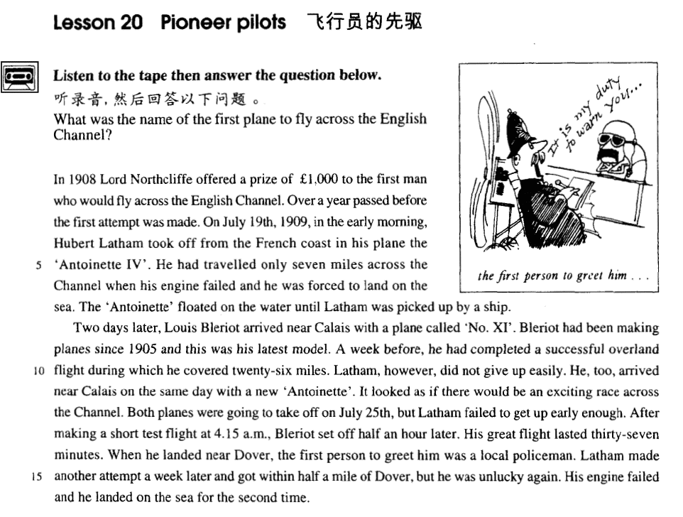

课文

In 1908 Lord Northcliffe offered a prize of ￡1,000 to the first man who would fly across the English Channel.

1908年，诺斯克利夫勋爵拿出1,000英镑，作为对第一个飞越英吉利海峡的人的奖励。

Over a year passed before the first attempt was made.

然而一年多过去了才有人出来尝试。

On July 19th, 1909, in the early morning, Hubert Latham took off from the French coast in his plane the ‘Antoinette IV.’

1909年7月19日凌晨，休伯特.莱瑟姆驾驶“安特瓦特4号”飞机从法国海岸起飞，

He had travelled only seven miles across the Channel when his engine failed and he was forced to land on the sea.

但他只在海峡上空飞行7英里，引擎就发生了故障，他只好降落在海面上。

The ‘Antoinette’ floated on the water until Latham was picked up by a ship.

“安特瓦特”号飞机在海上漂浮，后来有船经过，莱瑟姆方才获救。

Two days later, Louis Bleriot arrived near Calais with a plane called ‘No. XI’.

两天之后，路易斯.布莱里奥驾驶一名为“11号”的飞机来到加来附近。

Bleriot had been making planes since 1905 and this was his latest model.

布莱里奥从1905年起便开始研制飞机，“11号”飞机是他制作的最新型号。

A week before, he had completed a successful overland flight during which he covered 26 miles.

一周以前，他曾成功地进行了一次26英里的陆上飞行。

Latham, however, did not give up easily.

但是莱瑟姆不肯轻易罢休。

He, too, arrived near Calais on the same day with a new ‘Antoinette’.

同一天，他驾驶一架新的“安特瓦特”号飞机来到了加来附近。

It looked as if there would be an exciting race across the Channel.

看来会有一场激烈的飞越英吉利海峡的竞争。

Both planes were going to take off on July 25th, but Latham failed to get up early enough.

两天飞机都打算在7月25日起飞，但莱瑟姆那天起床晚了。

After making a short test flight at 4.15 a.m., Bleriot set off half an hour later.

布莱里奥凌晨4点15分作了一次短距离试飞，半小时后便正式出发了。

His great flight lasted 37 minutes.

他这次伟大的飞行持续37分钟。

When he landed near Dover, the first person to greet him was a local policeman.

当他在多佛着陆后，第一个迎接他的是当地一名警察。

Latham made another attempt a week later and got within half a mile of Dover, but he was unlucky again.

莱瑟姆一周以后也作了一次尝试，飞到离多佛不到半英里的地方。这次他又遭厄运，

His engine failed and he landed on the sea for the second time.

因引擎故障第二次降落在海面上。

词汇讲解

* **pioneer [paɪə’nɪə(r)]** n. 先驱；v. 开拓，探索

**Young Pioneers** 少先队

* Henry Ford was a **pioneer** in the auto industry.
* The Wright brothers **pioneered** in early aviation.

**break new ground** 开天辟地（开拓性工作）

* George Washington’ reform programs **broke new ground** in the United States of America.

**lead the way** 引路（做先行者）

* The company **led the way** in developing environment-friendly products.
* **lord** [lɔ:d] n. 对（英国）贵族的尊称，勋爵

**lord** n. 对贵族 (**noble** / **aristocrat**) 的尊称

* Lord Northcliffe 诺斯克利夫勋爵
* Lord Byron 拜伦勋爵

**英国贵族阶层：**

**duke** 公爵

**marquis** 侯爵

**earl** 伯爵

**viscount** 子爵

**baron** 男爵

**sir** n. 对爵士 (**knight**) 的尊称

* Sir John Hawkwood  霍克伍德爵士
* **overland** [‘əʊvəlænd] adj. 陆上的；adv. 通过陆路
* an overland journey 一次陆上的旅行

**overland** adv. 通过陆路 = **by land**

* We travelled **overland** / **by land** to Hangzhou.

**by sea** / **by air** 海路/空路

**by** **bus** / **train** / **car** / **ship** / **boat** / **plane** etc. 交通工具，介词**by**强调方式

**on foot** 徒步

**drive (from …) to …** 开车从…到..

**fly (from …) to …** 飞从…到..

**sail (from …) to …** 航行

**take** a **bus** / **train** / **car** / **ship** / **boat** / **plane** etc. 乘坐某个交通工具…

课文讲解

# *In 1908* Lord Northcliffe offered a prize of $1,000 to the first man who would fly across the English Channel.

知识点（一）

**offer sb. sth.** 给某人提供某个东西

**offer sth. to sb.** 给某人提供某个东西

**句式平衡，具体使用哪个看句子长度**

* In 1908 Lord Northcliffe offered a prize of £1,000 to *the first man who would fly across the English Channel*.
* An aeroplane offers *you* an unusual and breathtaking view of the world.
* Shops cater for the do-it-yourself craze not only by running special advisory services for novices, but by offering *consumers* bits and pieces which they can assemble at home.

**offer to do = volunteer to do** 主动提出去做某事

* In times of peace, when business was bad, Hawkwood and his men would march into a city-state and, after burning down a few farms, would **offer to go** away if protection money was paid to them.
* He **offered to train** Mendoza and his young pupil was quick to learn.

知识点（二）

* ~~a ￡1,000 of prize~~ **X错误**
* a prize of ￡1,000 √正确
* a ransom of ￡1,000 赎金
* a reward of ￡1,000 酬金
* a debt of ￡1,000 债务
* a fund of ￡1,000 基金
* a scholarship of ￡1,000 奖金
* an investment of ￡1,000 投资

知识点（三）

* **课后习题讲解：**

**4** The first man ___C___ across the English Channel would receive Lord Northcliffe’s prize. (11.1-2)

(a) who was going to fly (b) flying (c) to fly (d) having flown

**动词 + across + 宾语**

fly across the English Channel

**cross + 宾语 + 方式状语**

cross the English Channel by plane

知识点（四）

**the (English) Channel** 英吉利海峡

**strait** ***n.*** 海峡；困境

* the Bering **Strait**
* the Taiwan **Strait**

# Over a year passed before the first attempt was made.

知识点（一）

**知识点复习：**before 强调主句发生的时间特别长，before 要翻译成“才”；比预期的短要翻译成“就”，有的时候要翻译成“然后”。

* Looking at his watch, he saw that it was one o’clock, but the bell struck thirteen times **before**（才） it stopped.
* I hadn’t waited long **before** （就）he came.
* I shaved **before** （然后）I went to the party.
* Alfred stayed in the camp a week **before**（然后） he returned to Athelney.

**when** “才”“就”“然后”

* He had travelled only seven miles across the Channel **when** （就） his engine failed and he was forced to land on the sea.
* The plane had been planting seed for nearly a month **when**（才） it began to rain.
* Shrugging my shoulders, I began to walk away **when**（然后）, a moment later, he ran after me and thrust the pen into my hands.

知识点（二）

**make … attempt to do** 做尝试

**make an / no / little / the first / another attempt to do**

* Latham **made another attempt** a week later and got within half a mile of Dover, but he was unlucky again.
* **造句**：过了一个多月才有人发现了这具尸体。
* Over a month passed **before** the body was found.
* **造句**：过了十年 (decade) 多才有人出来揭示 (reveal) 了这个秘密。
* Over a decade passed **before** the secret was revealed.

# On July 19th, 1909, in the early morning, Hubert Latham took off from the French coast in his plane the ‘Antoinette IV.’

知识点（一）

**in the early/ late morning / afternoon / evening** 在早上/晚上/下午

**at** **dawn / the crack of dawn / daybreak / sunrise** 在凌晨

**at** **dusk / sunset / sundown / twilight** 在黄昏

知识点（二）

**take off**  起飞

**land** 着陆

* Flight No.714 **took off** / **landed** at 8:30 a.m.

**take off sth.** 脱衣服

**put on sth.** 穿衣服

* He **took off** / **put on** his coat.

**take … off …** 使……脱离……

* It is almost impossible to **take** your mind **off** the journey.
* She was so pretty—I couldn’t **take** my eyes **off** her.
* “Have you seen James without his beard?” “I know—it **takes** years **off** him!”（年轻好几岁）

**take time off** 请假

* --- Do you still live there?
* --- Oh yes, yes. My husband’s there now. He couldn’t **take time off** to come to New York with me.
* I have to **take time off from** work / school to go to the dentist.

**take a day off** 请一天假

**take the afternoon off** 请一下午假

# He had travelled only seven miles across the Channel when his engine failed and he was forced to land on the sea.

知识点（一）

travelled 本文强调走过了多长的距离，不强调方式

* He has to **travel** 20 miles to work every day.

知识点（二）

**fail** v. (fml.) （零部件）失灵

* The brakes **failed** and the car crashed into a tree.

**break down** v.（交通工具, 大型机器） 抛锚, 停止工作

* The car / bus / train / washing machine **broke down**.

**malfunction** v. (fml.) 出故障

* The satellite entered the orbit and quickly **malfunctioned**.

**sth. goes wrong with …** （口语化）出故障

* Something’s gone wrong with my computer.

**区分：fail to do** 没能完成某事

* When the journalist again **failed to reply**, the editor reluctantly published the article as it had originally been written.

知识点（三）

**be forced to do** 不得不

* She was **forced to retire** early due to ill health.
* … and he had to **make a forced landing.**

**be/feel obliged to do** 不得不做某事（强调道义，责任）

* However, as the evidence began to accumulate, experts from the Zoo **felt obliged to investigate**, for the descriptions given by people who claimed to have seen the puma were extraordinarily similar.

**be/feel compelled to do** 不得不做某事（强调外界压力）

* President Nixon **felt compelled to resign**.

**be/feel impelled to do** 不得不做某事（强调内心的动力）

* I **felt impelled to tell** her the truth.

**be / feel** **bound to do** 不得不做某事（强调由法律，协定）

* All the countries **are bound to submit** to the regulations.

**necessary**

* ~~be / feel necessary to do~~ **☓错误, necessary主语只能是it**
* It is necessary for … to do √正确

**must do / have to do** 不得不做某事(普通表达)

# The ‘Antoinette’ floated on the water until Latham was picked up by a ship.

知识点（一）

**float on the water** 飘在水面上

**ride the waves** 飘在水（大的）面上

知识点（二）

**pick up**(副词) **↔ sb.**

* I’d really like to **pick up** Grandpa at the railroad station. 开车接某人
* Railroad stations or airports, Grandpa always tells us he’ll get here by himself. He’s something!

知识点（三）

**save / rescue** 救某人、某事，（不强调方式）

* When you **rescued** your trousers, did you find the note was whiter than white?
* When a passing tanker **rescued** them five days later, both men were genuinely sorry that they had to leave.

**salvage** 只能表示救物资

* He tried desperately to salvage belongings from the burning house.
* The **salvage** operation had been a complete failure.

**pick up**(副词) ↔ **sth.** （多义词）1.捡起来；2.买到便宜货

* The phone rang and I **picked it up**.
* He has often described to me how he **picked up** **a masterpiece** for a mere ₤50.

**pick up where we left off** 从中断的地方继续

* After lunch shall **we pick up where we left off**?
* **老友记**
* Chandler: Wait! I just want you to know that ... I’m so happy you’re going to be here.
* Janice: Oh, me too ...
* Chandler: Because ... that way ... we can **pick up where we left off**.
* Janice: Huh?
* Chandler: I never stopped loving you.

# Two days later, Louis Bleriot arrived near Calais with a plane called ‘No. XI’.

知识点（一）

**法语名称发音，“s”不发音**

**Louis** 路易

**Illinois** 伊利诺伊

**Calais** 加来

**Charles** 查理

**Chamonix** 沙莫尼

知识点（二）

课文主人公介绍

**Louis Blériot** (1872-1936), French engineer and pioneer aviator.

After designing and building various types of experimental aircraft, he concentrated on developing the monoplane.

On July 25, 1909, he flew from Calais, France, to Dover, England, in one of his monoplanes, becoming the first aviator to cross the English Channel in a heavier-than-air machine.

During World War I Blériot’s factory produced about 10,000 airplanes for the armed forces of France and the other Allied powers.

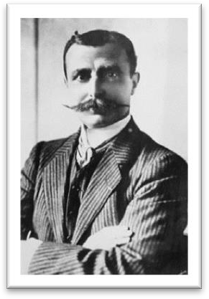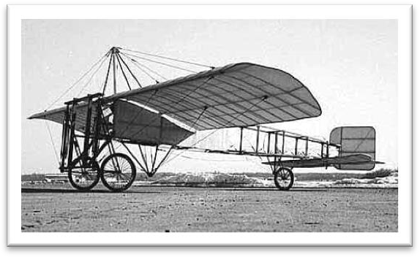

# Bleriot had been making planes since 1905 and this was his latest model.

**model** n.（车辆、机器的）型号

**the latest model** 最新型号

**the most popular model** 爆款

* My car is **the latest model.**
* They produce a range of different computers, but this is **the most popular model**.

# A week before, he had completed a successful overland flight during which he covered 26 miles.

可数 不可数

**flight** **aviation**

**voyage navigation**

* **造句**：早在 20 世纪 30 年代，红军就完成了长征，在这期间他们走过了 25,000 里。
* As long ago as the 1930’s, the Red Army had completed the Long March during which they covered 25,000 li.

# Latham, however, did not give up easily.

**stick it out** （习语）坚持下去

* Latham, however, **stuck it out.**
* **老友记**
* Rachel: Oh God, I hate my job, I hate it, I hate my job, I hate it.
* Monica: I know honey, I’m sorry.
* Rachel: Oh, I wanna quit, but then I think I should stick it out.

# He, too, arrived near Calais on the same day with a new ‘Antoinette’.

# It looked as if there would be an exciting race across the Channel.

知识点（一）

**It seems / looks as if / as though …** 看似, 好像……

* **造句**：看似他们之间将有一次激烈的争吵 (a heated argument)。
* It seemed / looked *as if / as though* there would be a heated argument between them.

知识点（二）

**race** 竞速比赛

* a car / boat/ horse / swimming race

**match**【英】 / **game**【美】 对垒比赛

* a boxing / basketball / football / volleyball match / **game**
* Boxing **matches** were very popular in England two hundred years ago.

**contest** 强调由裁判打分的比赛

* a speech / beauty / dance **contest**

知识点（三）

**promise to do** 很可能

* It **promised to be** an exciting race across the Channel.
* It **promises to be** warm today.
* **阅读真题：**
* Groundbreaking research by two French geophysicists **promises to shed** some light on the mystery.
* **课后习题讲解：**

**7**． It ___D___ to be an exciting race across the Channel. (11.1 1-12)

(a) would promise (b) would have promised (c) was promising (d) promised （表达将来的含义）

# Both planes were going to take off on July 25th, but Latham failed to get up early enough.

# After making a short test flight at 4.15 a.m., Bleriot set off half an hour later.

表达“**动身出发**”不强调方式：

**set out / off**

**start out / off**

* Four days after **setting out**, while the Titanic was sailing across the icy waters of the North Atlantic, a huge iceberg was suddenly spotted by a lookout.

# His great flight lasted 37 minutes.

# When he landed near Dover, the first person to greet him was a local policeman.

* The next man to **approach** me was selling expensive pens and watches.

# Latham made another attempt a week later and got within half a mile of Dover, but he was unlucky again.

**within … of …** 离……不到……

* I live **within** a mile **of** the city center.
* The company is **within** a week **of** bankruptcy.

# His engine failed and he landed on the sea for the second time.

**短语辨析：**

**for the second time** 第二次发生

**at the second time** 在第二次的时候

**for the first time** 首次做某次

**at the first time** 在第一次的时候

* In 1929, three years after his flight over the North Pole, the American explorer, R.E. Byrd, successfully flew over the South Pole **for the first time.**
* **走遍美国**
* Is something still wrong, Robbie?
* I’ll be OK.
* Going away to college **for the first time** always makes one a little nervous.
* I guess so. I’ll be OK. I just need time to think.